PROJECT DESIGN PHASE
Date | 31 January 2025
Team ID | LTVIP2026TMIDS73798
Project Name | Online Payments Fraud Detection Using Machine Learning

3.1 Problem Solution – Selected Algorithm
To solve the problem of detecting fraudulent online payment transactions, a supervised machine learning classification algorithm is required.
After analyzing different algorithms such as:
- Logistic Regression
- Decision Tree
- Support Vector Machine
- Random Forest
The selected algorithm for this project is:
🔹 Random Forest Classifier
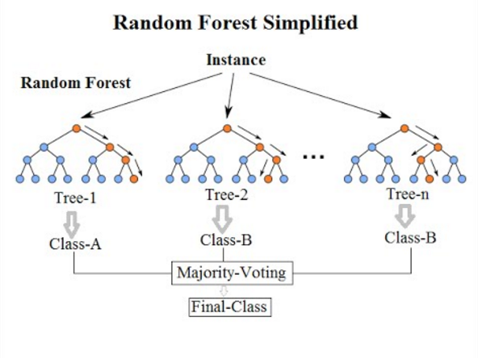

3.1.1 Description of Random Forest
Random Forest is an ensemble learning method used for classification and regression tasks. It operates by constructing multiple decision trees during training and outputs the majority vote (classification) of the individual trees.

Working Principle
- Multiple decision trees are created from random subsets of data.
- Each tree makes a prediction independently.
- Final prediction is decided using majority voting.
- For probability prediction, the average probability of all trees is calculated.

3.1.2 Why Random Forest is Selected
Random Forest is selected for the following reasons:
- High Accuracy - It generally provides better accuracy compared to single decision trees.
- Reduces Overfitting - Unlike a single decision tree, Random Forest reduces overfitting by averaging multiple trees.
- Handles Large Datasets Efficiently - Works well with structured financial transaction data.
- Handles Imbalanced Data Better - Fraud detection datasets are usually highly imbalanced (few fraud cases). Random Forest performs well in such conditions.
- Provides Probability Output - The model provides probability scores which help in risk classification (Low, Medium, High).

3.2 Proposed Solution
The proposed solution integrates the Random Forest model with a web application to provide real-time fraud detection.

3.2.1 Overall Proposed Model
The system works in the following stages:
- Data Collection
- Data Preprocessing
- Feature Encoding
- Model Training using Random Forest
- Model Evaluation
- Model Deployment via Streamlit

3.2.2 Model Training Process
- Transaction dataset is split into training and testing sets.
- Random Forest classifier is trained on training data.
- Model performance is evaluated using:
  - Accuracy
  - Precision
  - Recall
  - F1-Score
  - Confusion Matrix
3.2.3 Prediction Process in the Proposed System
When the user enters transaction details:
- Input data is validated.
- Transaction type is encoded numerically.
- Features are arranged in correct order.
- Input is passed to trained Random Forest model.
- Model calculates fraud probability.
- If probability ≥ 0.5 → Fraud
Else → Legitimate
3.2.4 Risk Level Classification
Based on predicted probability:
Probability Range | Risk Level
< 0.5 | Low Risk
0.5 – 0.79 | Medium Risk
≥ 0.8 | High Risk
This provides better interpretation instead of just binary output.
3.2.5 Advantages of Proposed Solution
- Real-time fraud detection
- Probability-based risk assessment
- User-friendly web interface
- Scalable to large datasets
- Easy deployment
3.2.6 Limitations
- Depends on quality of training data
- Cannot detect completely new fraud patterns without retraining
- Not integrated with real banking API

